Practical No. 4
Aim : ALP for multiplication of two 8-bit unsigned numbers
Name : Danish Altaf Solkar Class : CO - B
Enrolment no. : 24111590805 Batch : 2

Code :-
assume cs:code
assume ds:data
data segment
a DB 10H
b DB 20H
res DW ?
data ends
code segment
start:
MOV AX,data
MOV DS,AX
MOV AX,0000H
MOV AL,a
MOV BL,b
MUL BL
MOV res,AX
INT 03H
code ends
end start

OUTPUT :-
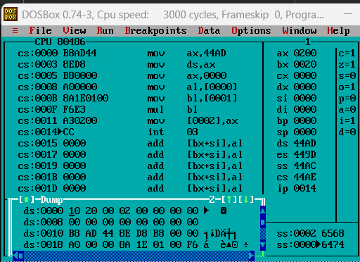

Process related  (15) | Product related  (10) | Total Marks  (25) | Signature

